*For more information about this*

*Our mailing address is Oasis Youth Ministries PO Box 445, Holbrook AZ 86025*

*ministry or to join our prayer*

*and support team,*

*you can go online to*

*www.oasisyouthministries.com*

Dear Friends and Family, August 2024

Hello! Greetings from a very hot high desert! We hope this finds you well.

School is starting back and Oasis Youth Ministries is getting ready to get back in the swing of things here in northeast Arizona.

We recently took a group of teens to the Phoenix area for an afternoon of pizza, rides, video games, laser tag, and bowling at a place called Jake’s Unlimited. As we have done the previous two years, we joined the youth group of First Baptist Church in Winslow, AZ and caravaned the three hours to the Valley. It was rather warm—the temperature was 116 degrees when we left to return home. The arcade itself, thankfully, was nice and cold inside. The two groups of teenagers seemed to get along and enjoy themselves. One unexpected joy was getting to see one of our former teens (now a helicopter pilot and instructor) who lives in the Phoenix area.

Due to everyone being out of town or busy, we have not had the Next Chapter for the past few weeks. We started back up on August 15. We will continue working through C. S. Lewis’s autobiographical allegory, *The Pilgrim’s Regress*, with our small group of young adults.

That same week, we also began the Well again, which is a weekly study and discussion for Christian teens in jr high and high school. It was a great first week turnout. The Jr High is walking through the book of Mark and learning how to read and study their bibles at home. They are also learning different ways they can talk to God. The High School is studying spiritual disciplines of the Christian faith this year.

We are continuing mentoring several young people and have more who need mentors. Please pray that we have some caring Christian adults who would be willing to step up to mentor some of our young teens.

We mentioned in our last letter that one of our young leaders was planning to extend her mission work in South Africa. She will be staying in Johannesbury until the end of November. Lord willing.

We have another student who just graduated high school, who just returned from a mission trip to Mongolia. It was a joy hearing of all the things God taught him while he was there.

Abigail plans to go to Uganda in just a couple weeks. She will be heading out from AZ on August 31 and will be in Uganda from September 2-13. Please pray for her journey, for the time they will spend sharing the Gospel from home to home (they will be working with South Sudanese refugees in the North), and for her team to be the hands and feet of Jesus.

It was also a blessing to have the opportunity to help First Assembly with their backpack distribution in the community. It was great to meet new kids and parents and know that our churches care very much in connecting with them.

*Prayer Requests:*

* *Pray for a students and leaders to continue to grow in Christ this fall.*
* *Pray for more leaders for Oasis for this upcoming school year.*
* *Pray for Abigail as she goes to Uganda to be the hands and feet of Jesus and that she would share Christ boldly.*

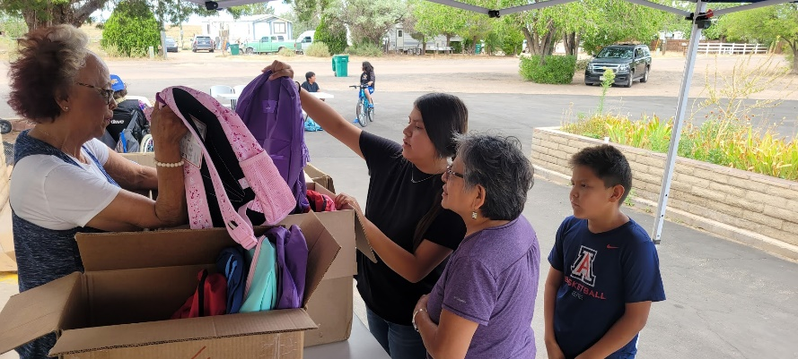

Thank you so very much for making it possible for Oasis to serve God here in northeastern Arizona; we could not do what God has called us to here without you! Your prayers and support make you *truly* part of the ministry here. May God richly bless you!

Grace and Peace,

Jerad and Carrie Burgess

Abi, Naomi & Sarah