*For more information about this*

*Our mailing address is Oasis Youth Ministries PO Box 445, Holbrook AZ 86025*

*ministry or to join our prayer*

*and support team,*

*you can go online to*

*www.oasisyouthministries.com*

Dear Friends and Family, September 2024

Hello! We hope this finds you well! September is here and we are (probably like you) looking forward to cooler weather, although it is not here yet. We recently took 15 young people on a hayride given by a very generous local rancher named Bill, on his enormous ranch. He and his wife have been big supporters of the ministry even before we moved here and have been a tremendous blessing to us these 8+ years. As we have done in other years (usually later in the fall, when it is a bit cooler), we went out to an area filled with large sand dunes. The teens played games and with much laughter hurled themselves down the dunes; we had a bonfire and cooked hot dogs and made s’mores; there was a lovely sunset and curtains of rain far in the distance.

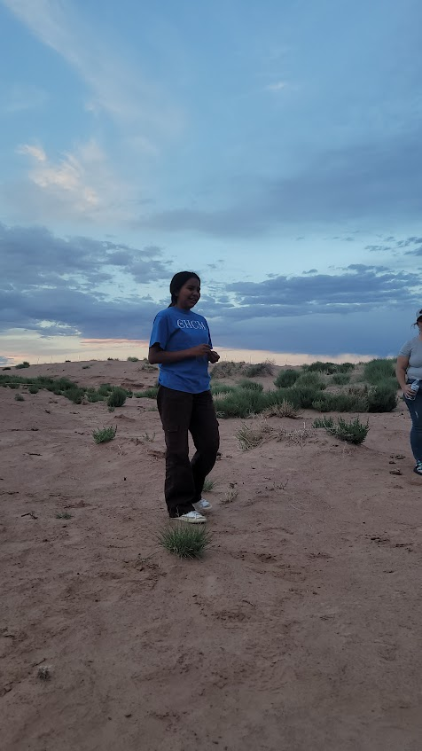

One of our recent high school graduates, a young Navajo lady, for the first time shared her testimony while everyone else sat and listened at the base of a large dune. She was very nervous, and did not want to do it, although she felt like she should. After much encouragement she gave a very emotional account of her story of coming to the Lord. All I can say is that it was powerful. You could have heard a pin drop. One excellent point that she brought out was that God’s standards of righteousness are far beyond our reaching; there is no amount of good works we can do that will put us back in His good graces. That is why He sent Jesus to live a perfectly moral, totally God-pleasing life in all ways, meeting for us the enormously high demands of God’s righteousness. Although she was not aware of it, this is exactly what some of the students there needed to hear. We could not meet God’s standards, so God met them for us in Christ; He paid our debt to Him in His death and resurrection and all we have to do is put our trust in Him and what He already accomplished. We were very proud of this young lady for stepping out—very far out—of her comfort zone and speaking of what God has done in her life. We returned back in the near dark with a nice, dusty breeze. It was an excellent event—the teens seemed to enjoy it and we all got to hear of God’s life-changing goodness. Special thanks are due to Bill for making this event happen!

The Well is going well, although we did not have it this past Monday evening due to the Labor Day holiday. The jr high group is continuing to work through the Gospel of Mark. The high school students are going through a book on the spiritual disciplines of the Christian faith. We recently looked at “Bible intake” through hearing it, reading it, and studying it. The students were given “homework” of seeing that at some point each day they are to, in one of these ways, put the scripture into their minds and hearts.



Our daughter, Abigail, recently returned from a mission trip in Uganda where she was able to share the Gospel many times and see people receive Christ! We appreciate your ongoing prayer for her in this physical and spiritual journey.

*Prayer Requests:*

* *Pray for a students and leaders to continue to grow in Christ this fall.*
* *Pray for more leaders for Oasis for this upcoming school year.*
* *Pray for our leaders as they prepare their favorite “life-changing” Jesus story to share with our students each month.*

Thank you so very much for making it possible for Oasis to serve God here in northeastern Arizona; we could not do what God has called us to here without you! Your prayers and support make you *truly* part of the ministry here. May God richly bless you!

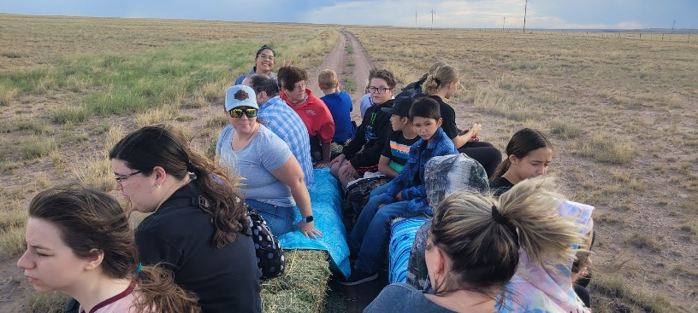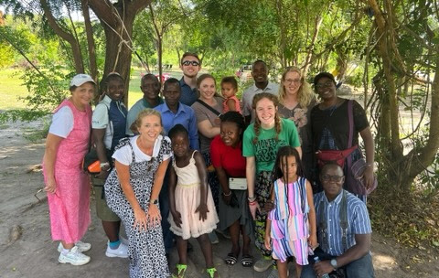

Grace and Peace,

Jerad and Carrie Burgess

Abi, Naomi & Sarah