*For more information about this*

*Our mailing address is Oasis Youth Ministries PO Box 445, Holbrook AZ 86025*

*ministry or to join our prayer*

*and support team,*

*you can go online to*

*www.oasisyouthministries.com*

Dear Friends and Family, October 2024

Hello, you wonderful people! We pray you are doing well! Thank you so much, as always, for your ongoing support of this ministry. We know you are sacrificing in this difficult economy. Please know how much we appreciate your prayers and finacial support that makes this ministry possible.

We recently took a small group of teens on a hike in the mountains that was very refreshing and beautiful; the sun was shining and there was a slight breeze. We saw a herd of wild horses running among the ponderosa pines as we walked, and they stopped and stared at us warily before we moved on. We also heard the bugling of elk, but in spite of the efforts of two of our young men, we did not find them. We stopped and rested on downed trees while Jerad gave a short talk from Luke 24:13-35 about trusting God and His purposes even when life does not make sense, and how the presence of the risen Christ radically changed these downcast disciples. We finished the hike and then stopped by Dairy Queen (at the teens’ request) for ice cream, replacing all the calories we had just burned.

Our next event we are planning to do is our yearly autumnal trip to the corn maze in Snowflake, AZ. Besides conquering the maze, we pick pumpkins, play laser tag in a corn field in the dark, and eat pizza around a fire pit. We are looking forward to having one of our former high school students, Taven, give the “talk” to the teens about how Jesus changes lives. He went on a mission trip this past summer to Mongolia and is a young man who is seeking to grow in his faith. We are thrilled to have him involved with this ministry!

It should be a great time.

Our weekly ministries, the Well and the Next Chapter, are ongoing. In the Well the jr high kids are continuing their trek through Mark’s Gospel, and the high school has been continuing to learn to put the spiritual disciplines into practice in their lives. The group is also going to memorize the letter of 2nd John by the end of the semester.

On another note, please be in prayer for our nation as we near election day in November. I would also like to encourage you to vote! The stakes are enormously high, and we as followers of Christ need to take advantage of the right to have a say in who leads us and what decisions are made in our great nation.

*Prayer Requests:*

* *Pray for students and leaders to continue to grow in Christ this fall.*
* *Pray for more leaders for Oasis for this upcoming school year.*
* *Pray for our leaders as they prepare their favorite “life-changing” Jesus story to share with our students each month.*
* *The future of our nation.*

Thank you so very much for making it possible for Oasis to serve God here in northeastern Arizona; we could not do what God has called us to here without you! Your prayers and support make you *truly* part of the ministry here. May God richly bless you!

Grace and Peace,

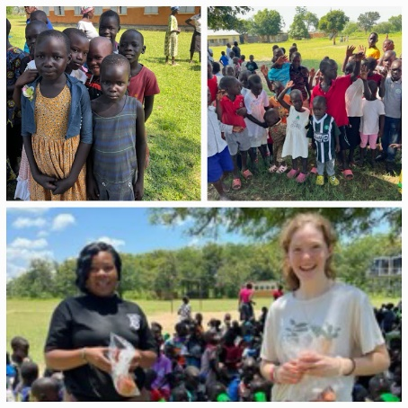Jerad and Carrie Burgess

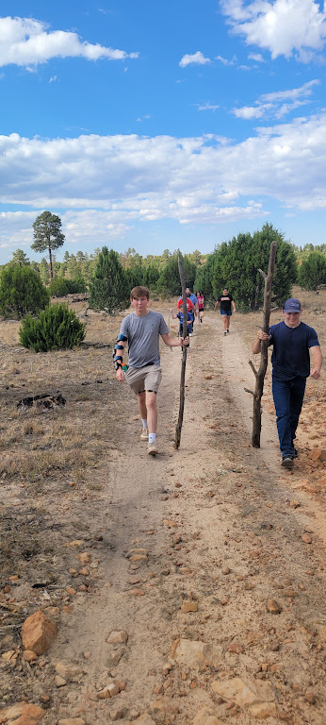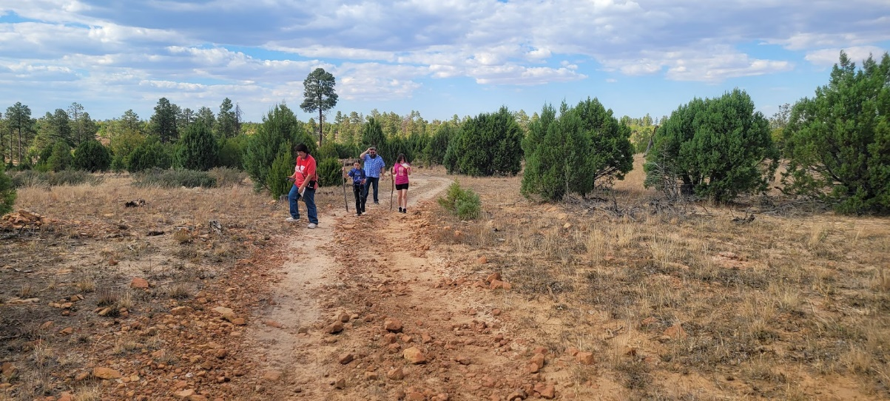Abi, Naomi, & Sarah

Hiking in Apache-Sitgreaves National Forest

Abi’s Mission trip to Uganda in September